Research Strategy Default Backtest Report
Strategy / EA: TRB V2.0
Expert: TRB V2.0.ex5 | Symbol: USDJPY Dukascopy | Timeframe: M15
Backtest Period: 2013.01.01 -> 2026.07.03 | Initial Deposit: $2,500.00
Generated: 2026-09-23 08:34:40 UTC
This report documents the DEFAULT (un-optimised baseline) backtest for this researched strategy. It establishes baseline performance and trade mechanics directly from the EA's core MQL5 implementation prior to running genetic parameter optimization and robustness stress-tests.

Key Performance Metrics
Metric | Value
Net Profit ($) | 681.7700
Net Profit (%) | 27.2708
Profit Factor | 1.2600
Sharpe Ratio | 3.3500
Max Balance Drawdown (%) | 8.4600
Recovery Factor | 2.1600
Win Rate (%) | 52.2300
Total Trades | 247
Largest Profit Trade ($) | 138.9900
Largest Loss Trade ($) | -108.0600

Equity & Performance Charts
Chart Equity Growth
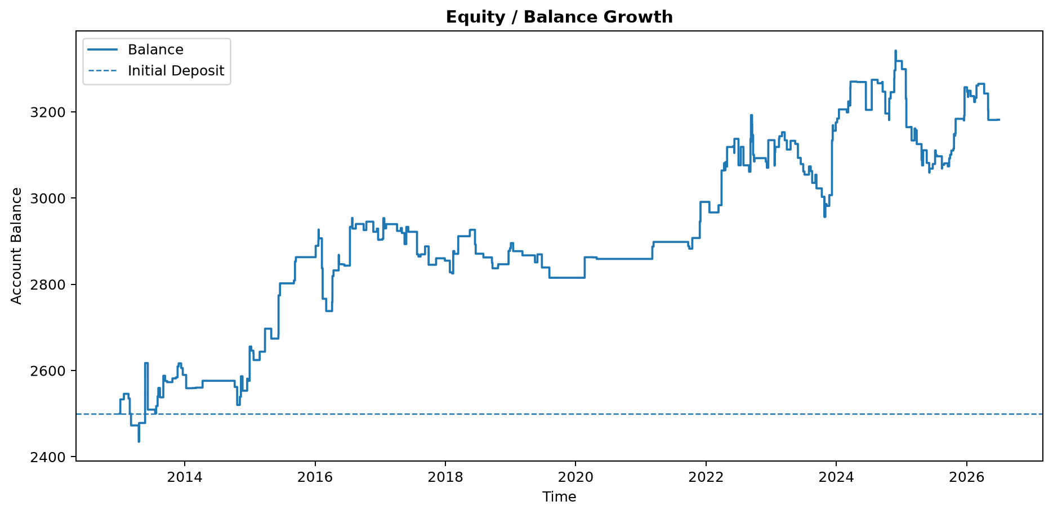

Chart Percent Gain
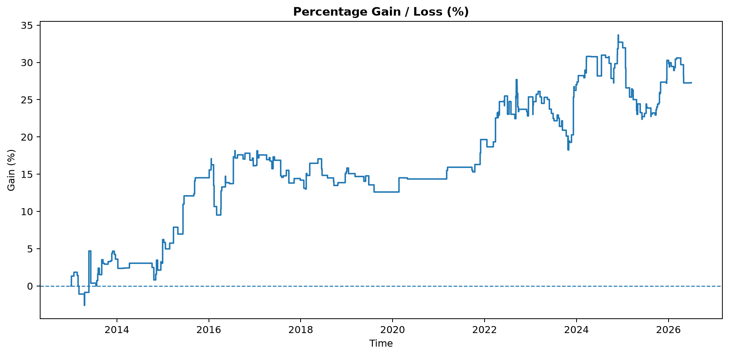

Chart Profit Dollars
